Results information – Accessing eILP

For this academic year, A Level results can be accessed on:

A Levels - 17th August 09:00 at Loxton Campus AND/OR via your eILP.
All other Level 3 Programmes (BTEC, T levels etc) - 17th August 09:00 via your eILP
GCSE - 17th August 09:00 at Knightstone Campus AND/OR via your eILP
Level 2 BTEC - 17th August 09:00 via your eILP

A copy of your printed results will also be sent out to your address within a week of results day

Please check your access to eILP prior to results day to familiarise yourself with this platform

Accessing results

Guidance on accessing your results on eILP is shown below:

- Log into your eILP using your Username (WS number) and password (like you use to log onto PCs in college)
- Click on the “My ILP”


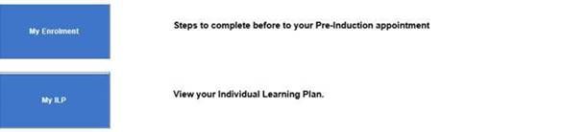

- Click on the ‘Exams’ tab on the left of your screen:
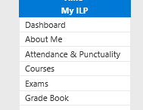

- Your grade will show against the description name of the course you have completed. Change the ‘Academic Year’ drop down to 2022/23:

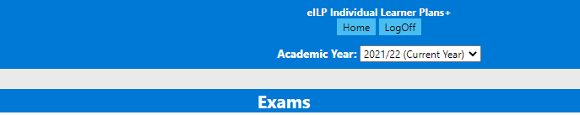
2022/23

