A copy of your printed results will also be sent out to your address within a week of results day

Please check your access to eILP prior to results day to familiarise yourself with this platform

Accessing results

Guidance on accessing your results on eILP is shown below:

- Log into your eILP using your Username (WS number) and password (like you use to log onto PCs in college)
- Click on the “My ILP”


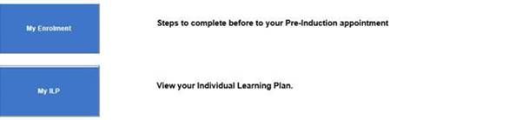

- Click on the ‘Exams’ tab on the left of your screen:
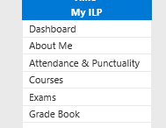

- Your grade will show against the description name of the course you have completed. Change the ‘Academic Year’ drop down to 2024/25:

